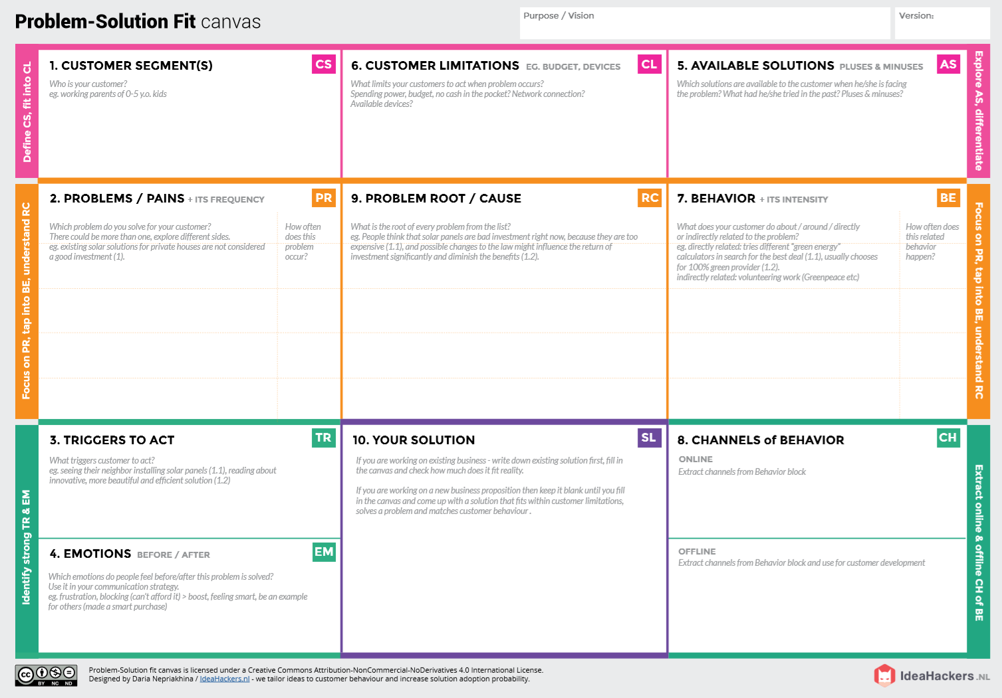 **PROJECT DESIGN PHASE-1**

**OFFLINE**: The control action is taken by the farmers to monitor the farms.

**ONLINE:** The Data is sent to the application through the sensors for the farmers

**Direct related**: A solution using IOT to solve this problem

**Indirect related**: Internet connectivity may not be strong in rural areas so the data transmission speed may be slow

Monitor different parameters like pH temperature, any movement of animals and an application is made to retrieve data easily from the farm using IOT.

***“IoT based Smart crop protection system for agriculture”***

It provides more yield by protecting crops from pests, diseases and weeds as well as animals and heavy rainfall.

1)Any intrusion of animals may destroy the crops and pave way to heavy loss

2)If it results in less productivity, it will affect in farmer’s profit.

3)Smart agriculture needs availability of internet continously

* Safety comes first
* High volume yields
* High maintenance costs
* Security of data
* It is difficult to monitor and control the farm
* Not sure if it works under all climatic conditions
* The integration of these sensors and tying the sensor data to the analytics driving automation and response activities.

Farmers and owners who are not near their field

Finding solutions to improve the rural life and ease their way of farming

**BEFORE**: Debts, heavy manual work, difficult to monitor

**AFTER**: It will provide more yield in the field

**PROBLEM S0LUTION FIT**